Essay: Ross Gibsonon Alexandria

Flow Charts: Alexandria
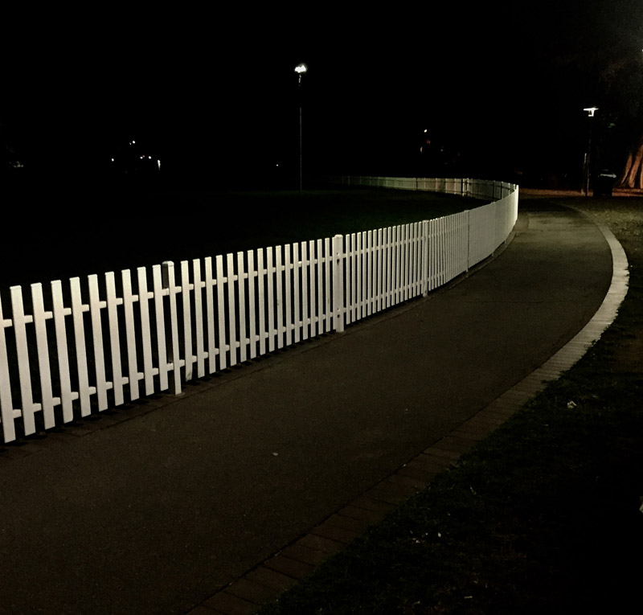
Most of us know the story from January 1788, about how Botany Bay was deemed inhospitable by the First Fleet of British interlopers. Within days of arriving at the Bay, the flotilla packed up and hauled around to the dumb good luck of a deepwater harbour that a search party had found glittering behind a break in the ramparted coastline. While tacking north, the astonished colonists looked back to see a pair of French ships edge into Botany Bay. After the parvenus dropped anchor near the strand that is now known as Frenchman’s Beach fringing the suburb now called La Perouse, the British dispatched a reconnaissance squad. It took only a few minutes of bilingual negotiation to establish both that the French were just looking to replenish for a few weeks, and that the British were the ones with the firepower and military personnel sufficient for seizing a permanent garrison. As local tribes watched all this unfolding, they called out ‘wara wara’ several times, which depending on context could be variously translated as ‘wrong move’, ‘not so fast’, ‘be careful’, or more bluntly and most likely, ‘go away, go away’.
Less well known is the tale of a gaggle of convicts who scarpered cross-country out of the re-located British encampment, in quest of the French ships, hoping to sneak aboard and get cargoed away from jail. When the runaways came over the sandhills, the French declined to help, forcing the frazzled convicts back into the wilds until most of them re-traced the path to Sydney Cove, where ceremonies of punishment ensued.
The incident warrants no more than a paragraph or two in a couple of the First Fleet journals. The writers had grander exploits to depict. But I can’t skip over it so easily. There’s such enticing detail to imagine, such wonderment that the journal-writers did not record. How did the convicts organise themselves before and during their treks? Who amongst them had navigational savvy? How did they fare, camping rough? Did they learn to catch food and draw water in country? What transactions occurred with the local Aboriginal people who would have tracked their every step?
And last comes the question I’m always pondering: what route might they have taken? The convicts must have felt like astronauts. When I consult a map to discern a plausible path from the place we now call Circular Quay to Frenchman’s Beach, from unknown to unknown, I’m convinced the convicts trekked close by the lull of land where my house now sits, in Alexandria.
Realistically, the runaways had only two options. From Circular Quay they could have headed east in wooded terrain to the coast, working their way up and over sandstone outcrops and canyon bluffs. Think of the humped country from Dover Heights – across to the full undulated extent of Carrington Road and further south. If they had gone this way they would then have struggled to follow the beachline down, encountering rocky headland after headland. Alternatively and much more likely, they could have skirted west of the rises that we now know as Redfern and Surry Hills, to walk mostly unimpeded through the sandy lowlands that flow in a southeasterly arc from modern-day Alexandria through Rosebery, Banksmeadow and Matraville to La Perouse. Provided someone amongst them had navigational smarts (which is probable, given how many country-folk were in the prison-ships), they could have sauntered the seventeen kilometres without too much duress, taking care to edge around boggy marsh patches and quicksand sinks while kangaroos bounded about, birds squawked, insects stung and Aboriginal people watched, followed and shouted.
I’ve thought about this journey almost every day of my 26 years in Buckland Street. Every day I too hear shouting Aboriginal voices, as shaiacking kids flow in and out of Alexandria Park Community School across the road. Sometimes I get humorously caught in the middle of them while they track and trick with me, especially if I’m walking my dogs.

Alexandria is a place animated by flow-lines. When I first came to town in the early 1980s, I glommed on to the suburb not only because of its smattering of small, habitable warehouses and run-down factories but also on account of the road system that veins within it and out from it. From Alexandria you can motor north, south, east and west with equal facility (which is not to say ‘with ease’). This ganglion of arterial roads is why Alexandria became the warehouse district. There’s direct access to the airport and to the container docks at Botany. From storage sheds and industrial estates, lorries beetle in all directions. If you live in Alexandria and you don’t get stymied by the first impression of its profit-maximal ugliness and its archipelago-layout amidst the capillaried divagations of the traffic-flows, then you quickly appreciate how the entire city lolls equally available to you on all sides. It’s the reason I came here. The beaches, the CBD, the inner-west, the inner-east, the airport, the coastal escapes north and south, the routes west over the mountains and out to the tablelands are all on offer. This compass-splay is unusual in a metropolis where people usually get caught siphoning in-&-out along strangulated fume-trails like Parramatta Rd, Victoria Rd, the Princes Highway, the Hume Highway, Military Road, Anzac Parade, Bondi Road, and all the clogged motorways. (Every Sydney-sider hates some particular bottleneck. Don’t get me started about Lachlan Street in Waterloo, disdained in our family as ‘Enragement Road’!)
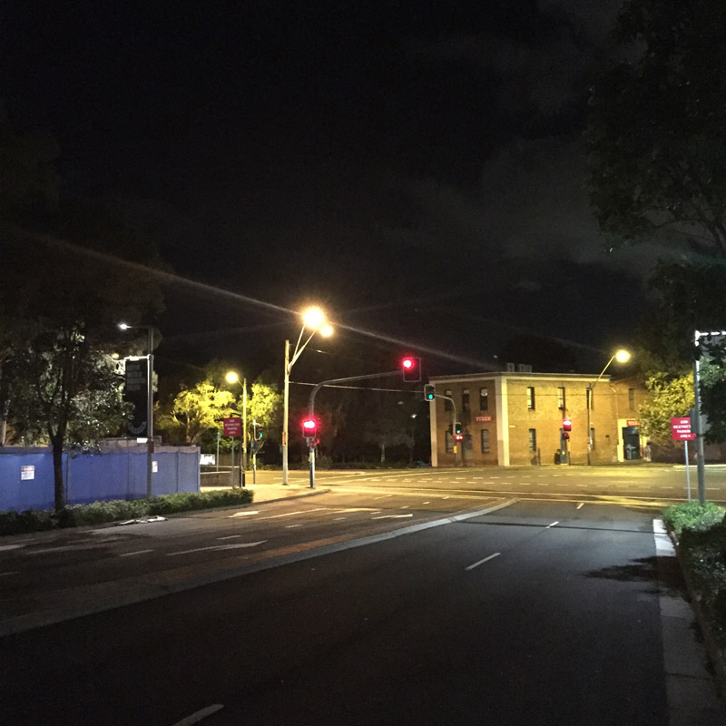
So, here in my home-base of Alexandria, the traffic gets me thinking about flow every day. With the convicts and Aborigines in mind, I think about how the modern roads connecting to La Perouse actually trace the flow-path of an ancient sandy river-wash, just as the runaways did in 1788. I think about how the flood-prone lowlands that slump out of Alexandria through Zetland, Rosebery and Banksmeadow flow south to ghost a now-defunct estuary flush that once seeped to the coast. Finding the flow-lines mostly devoid of groundwater in summer, the convicts would simply have followed the path of least resistance down to Botany Bay.
With Alexandria’s sandy topsoil in mind, I think too about the liquid creep of toxins (known rather poetically as the ‘Mascot Plume’) that has been sneaking back north through the loamy water table towards the CBD ever since a series of chemical spills soaked the ground near the airport during the late 1980s and early 1990s. I know about this slow-flowing plume because my local council requires a ground-contamination analysis whenever an Alexandria citizen proposes digging into the topsoil to lay foundations for renovations or property extensions. If the inspectors find gunk, you pay top-dollar for soil-reclamation. Or you just band-aid the breach and talk to the architect about going up rather than down. So I think too about the flow of money, especially when I see the enormous WestConnex scour-troughs and the sundry tunnel-boring projects churning across Alexandria. I think about who pays whom to make the toxins disappear, maybe by dragging them away to dumping-grounds in poverty-strapped municipalities elsewhere, or maybe by failing to find plume in opportunistic assays augured selectively into carefully pinpointed plots of clean inspection ground.
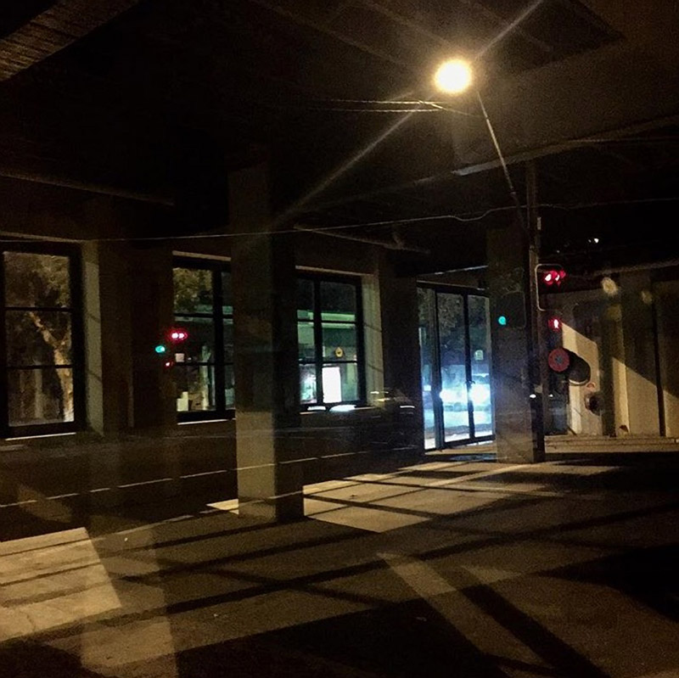

Pondering Alexandria’s flows and the underworld, I recall a couple of personal encounters. The first is from the momentous day in the summer of 1992 when, without any real plan to make the money that was needed, I bought the idiosyncratic little factory that I still call home. I’d snaffled a bargain directly from a bank which had scooped the small building as petty junk in the wave of insolvencies during Paul Keating’s ‘recession we had to have’. Steal that I now understand it to be, it felt at the time like an impossible load of money. It was my inaugural purchase at this scale; my first mendacious tangle with banks, solicitors, council and the mind-steaming, hyphenated, mathematical conjure-trick that is mortgage-financing.
Boggled with the ‘what-have-I-done’ panic that every first-timer to Sydney home-ownership must confront, I closed the unlockable, ant-eaten door on the property and staggered through the heat to Alexandria Park. In those days the park was not the manicured sanctuary it is today. It was part rubbish-heap, part dirt-bike scramble. And part body-dump. Seriously, tragically. Livid in everyone’s awareness at that time were the horrific Erskineville Alexandria gay-hate murders that had occurred during 1988 to 1990, followed by the ‘Alexandria Eight’ trial which exposed ghastly predations around the gay beats of the district. Over in the park on the day I took possession, there was nobody around, except for a quiet and hard but vulnerable looking guy in his thirties, sitting on a bench. Spooked with my own private melodrama – ‘WHAT-HAVE-I-DONE’ – I skirted around and away from him and feigned not to hear when he called out to me. The sweat really started to pop when he yelled and short-stepped fast toward me.
When he stopped at arm’s length from my chin, swaying a little as if trying to balance habitual menace with experimental amenability, he was sharp with his demand: he needed money because he’d just got out of Long Bay where the screws had put him on a bus with nothing but the ill-fitting clothes he had on him. He had bailed from the bus before he got to the city. The city would have done his head in. But he really needed some money right now. And he announced, ‘As a now-deceased mate of mine used to say, “I am clearly not a gentleman with whom one should fuck”’. He even waggled the quote-fingers when he uttered the last statement.
I’m still bemused about what I did next. Cartoon-style, clueless, I stood there in front of him and pulled all my pockets inside-out, decanting a ten-dollar note and a few bucks of gold coins. Nothing else. Not even a key. I handed him the meagre loot and stood there quietly freaked, pockets akimbo. Which is when he let a goofy grin split his scarred visage before saying, ‘Look at you, ya dumb bastard!’ And … the way these things can go when you get lucky, we both broke out laughing. Each of us a little bit richer now, he turned and took off up the ridge toward Redfern.
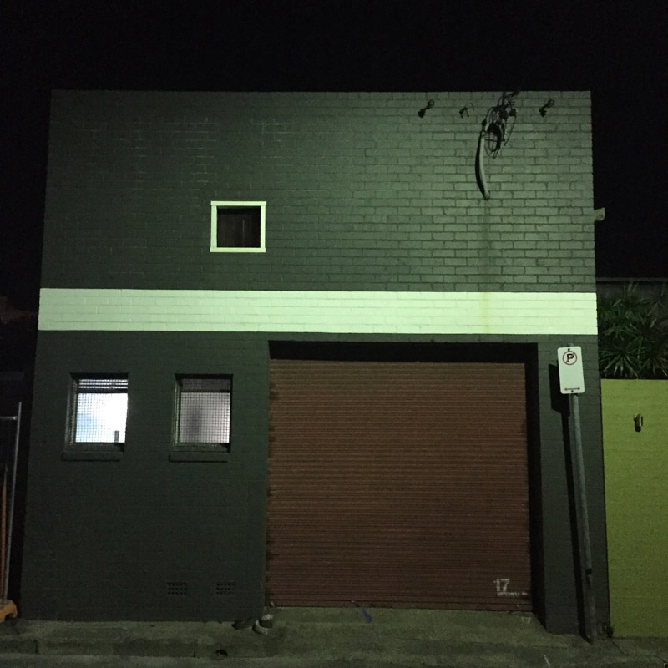
My other scrape with the Alexandria underworld also involved some odd language. In the weeks after I took possession of the factory, I was camping there amidst saws and hammers and crappy cheap power tools, wishing I’d paid more attention in the childhood years when I occasionally tagged along with my carpenter dad as he went out on renovation-jobs in the fringe suburbs of Brisbane. Through the first weeks of occupying the Alexandria factory, on successive Thursday mornings, a retinue of increasingly angry individuals banged on the ant-eaten door and demanded to speak with Richard. Each time, I explained that I was the new custodian, that there was no Richard nearby, that I had not the faintest idea who Richard was or where he might have gone. With each fresh encounter, the inquisitor was slower to leave and harder to appease. The fourth Thursday, the banging on the door was like a series of axe-blows. The guy standing a pace away on the footpath was formidable.
I gave my customary account and without thinking about the words I was babbling, I finished by blurting that a slew of guys like him have been banging on the door for the past month, and I didn’t know what more to say about it. A kind of gear-shift moved through the man’s posture and altered his face. ‘Slew!’ he said. ‘What sort of a word is that?’ I had to think about it. Had I really said that word? Where did it come from? ‘Ummnn,’ I extemporised, ‘“BUNCH” … I meant “bunch” … a bunch of guys.’ ‘Yeah,’ he batted back, ‘I know what you meant. But you said “slew”. Where’d that come from?’ I really had to think about it. The whole scene was turning weird enough for me to just surrender to it and take his curiosity seriously. I mused that it was a word I didn’t use much but it came from my dad, that he and his buddies in Brisbane used to say it quite a bit. I guessed I just absorbed it from him and it popped out of my mouth without my thinking about it. ‘Yeah,’ said the guy, ‘It’s a Brisbane word. My dad used to say it too.’
Something seemed to have shifted. He was still worrisome but I was no longer sensing imminent damage. Even so, I had no idea how to convince him that this Richard thing had nothing to do with me and that I really needed the Thursday visits to stop. So I invited him in to have a look around. ‘See for yourself.’ Which he did. The guy scrutinised the bare factory, scanning the puddle marks on the concrete slab beneath where the roof was leaking, appreciating the wonky timber framework and the gyprock panels leaning hither and yon, until he peered at me, morose in my grubby work clothes and muttered: “’Look at you, ya dumb bastard!’ Then he strode back along the footpath, quipping over his shoulder that they would not be troubling me anymore. Thirteen hundred Thursdays later, he’s been true to his word.
So you can see why criminality is never far from my mind in Alexandria. It always overlays my abiding idea that flow determines the character of the place by way of the suburb’s topography and the layout of its road system. Combining these two defining themes – criminality and layout – I often think about how Alexandria sprawls for me as a vast materialised metaphor of what I’ve come to understand as the immoral structure of Sydney.
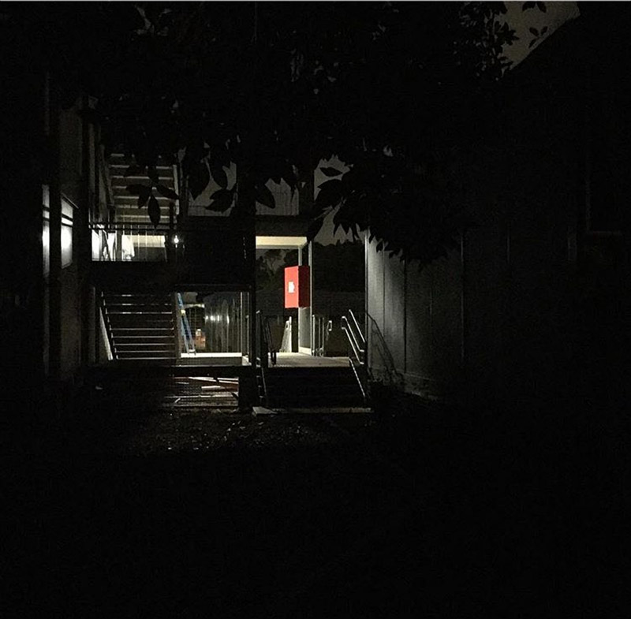

To grasp my thesis about how Alexandria’s built form manifests the mean animus of the city all around it, you have to add the following qualities of the suburb:
the barely-governed engine of property-development pumps thousands of new mortgage-serfs annually into Green Square and out along O’Riordan Street and Bourke Road, rolling quick-profit cycles for private companies and condemning the citizenry to festered decades of waiting while public facilities stagger and fail to catch up;
the traffic system of Alexandria splays and gurgles like a monstrous monument to the state government’s long-term collusion with fossil-fuel industries and a car culture that promotes individualist indulgence instead of responsible approaches to sustainable services such as public-transport innovations and asset-sharing;
the state government drains license-fee bonanzas from the myriad pubs and poker-machine swill-halls and TAB shops that remain dug in amidst Alexandria’s new gourmet-food hangars and factory-conversion speakeasy bars, such that generation after generation of chancers and oblivion-seekers keep boozing and betting inside a communal habit that was laid down two hundred years ago, the upshot being that decade after decade the troika of Government-Gambling-and-Grog continues its win-win-win profiteering.
When you combine these Alexandrian characteristics, you get an energy-source that empowers the traditional ‘fist of exploitation’ in Sydney, a fist that is still gripping my suburb in the same way it has throttled the entire town ever since the Brits arrived.
The fist of exploitation? It takes half a second to see it in the mind’s eyes, but it needs a little longer to explain using words.
Described in short-hand, this is how the fist clenches. From the moment the British interlopers arrived, four powerful separate ‘fingers’ have always reached across Sydney, combining the town’s defining qualities, controlling the town and squeezing wealth from it. These four fingers make up the fist:
1) land-grabbing and property ‘development’;
2) primary-resource extraction (especially timber-felling, coal-digging, gas extraction and a loyalty to the petrol engine);
3) the licensed control of liquor (think of the 1808 Rum Rebellion);
4) the licensed control of gambling.
To the extent that the Government thinks it wields the fist, the politicians have always regarded the Police Force as the blunt thumb – the fifth brutal digit — that clamps around the four fingers to hold the town in the fist of exploitation. On the other hand, to the extent that the Police think they wield the fist, they treat the Government as the thumb. Either way, the throttled citizens themselves never get free and there is no quick way to change how the grabby Sydney economy functions.
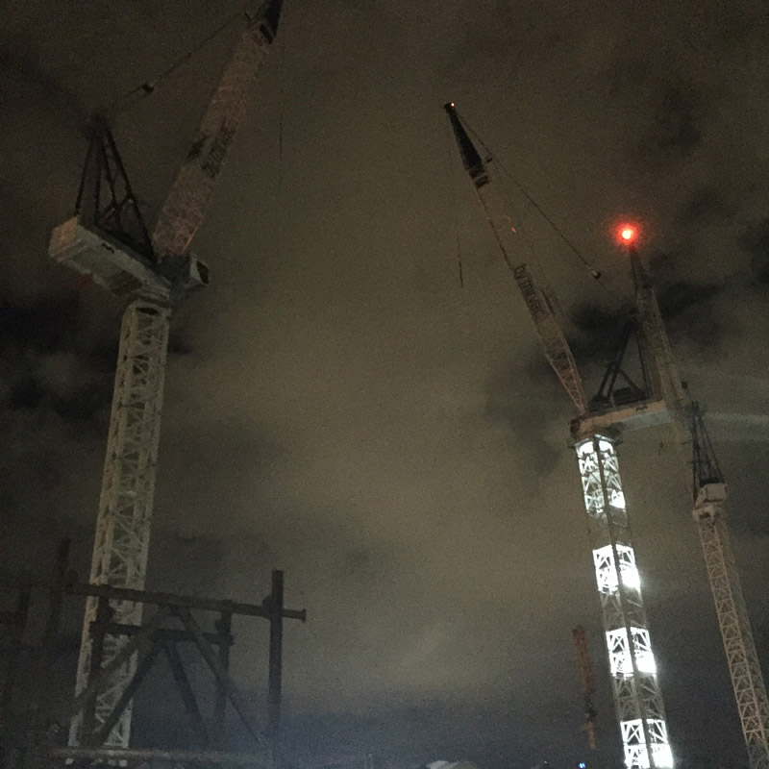
Be it police-thumbed or government-thumbed, the fist is locked, centuries old and in service of interdependent cabals that dollop dollars on one another: property developers, parasites on gambling, profiteers from liquor, plus primary resource extractors and careless greenhouse gassers. And to keep it interesting, no matter how much the government or the police might think they bind the fist, the fingers always snap the thumb painfully back at the first hint of misalignment. Think of how the gambling industry and the greyhound-racing ‘fraternity’ mauled Mike Baird when he got out of line; think of the way property developers and mortgage-managers always threaten the state budget; ditto the casino-operators; think of the intransigence of the hoteliers and liquor-peddlers and how the government has so long favoured licensed relations with billion-dollar cartels rather than permitting citizens to congregate away from the brewery-owned franchise-barns, in the intimate mixed-business bars and idiosyncratic bolt-holes that are clearly preferred when available. Think too of WestConnex and the authorities’ fealty to the old carbon-fuelled economy.
So you can see how the fist has been shaping the town’s neighbourhoods uninterrupted for more than two centuries, ever since the convict days. Unclenching the fist requires political will but such resolve is never in evidence, for the fist-forces – Government, Police, Property Development, Extractive Industry, Gambling and Booze – all profit off one another and protect one another and thus keep the citizenry wrung.

In fact there’s more to this old thrall than just brute political power. There’s a kind of anaesthetic in the town that keeps us citizens placid and in place and helps us endure the pain. We tend to comply with the fist as if drugged well past caring. Ironically the anaesthetic that lulls us is mainly aesthetic. The beauty of the town is its blessing and its curse insofar as the beauty is what anaesthetises us and persuades us to carry on despite the force of the fist. The beauty is the reward for sticking around and there is enough aesthetic wallop left to spare even after the wielders of the fist have extracted the sweetest draughts for themselves.
Every Sydney-sider has felt the anaesthetic working at some time or other. The corruption, the inefficiency, the carelessness and the grabbiness all drive you to the point of leaving. And then, at least weekly, the town gives one of those Sydney days when the ocean’s in the breezes and the light emits its ubiquitous golden sparkle; or you get one of those Sydney nights when wattle-nectar wafts and the bats and plovers and storm-birds squawk up their spooky sorcery. At such aesthetic moments you find yourself anaesthetised and saying again weakly, ‘OK, you are beautiful and I can’t walk away!’
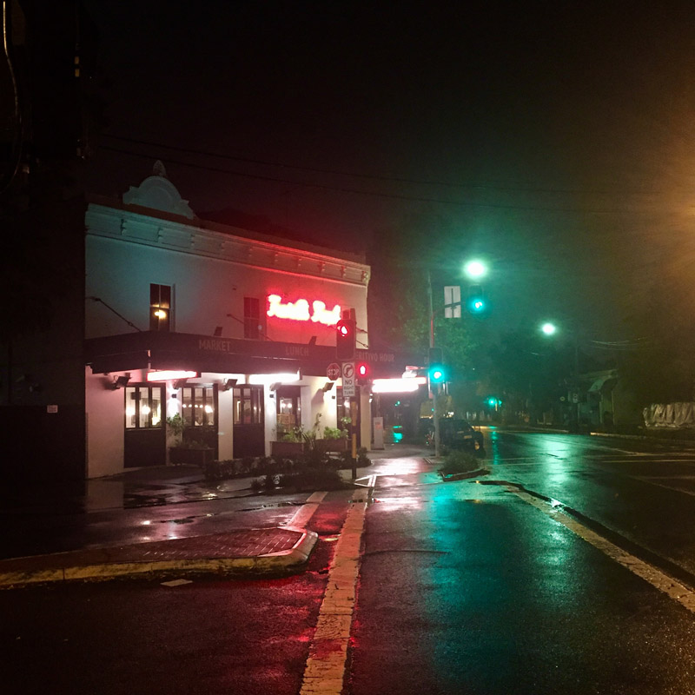
Even in Alexandria, or rather especially in Alexandria, one can see how it works. After all my talk of the heat-struck ugliness and exploitation in my suburb, I have to confess that I am also beguiled by the opposite, by the night-time, Alexandrian version of the anaesthetics. (It’s why this essay is peppered pictorially with so many night-scenes.) My own beguiling started eight years ago when our household succumbed to the inevitability, in this dog-obsessed suburb, by acquiring a pair of sight-hounds. The hounds take me out walking the neighbourhood nightly as well as daily. And the night-time is a revelation. With my hefty, retired racing-dog trotting bodyguard at my heel no-one stops in the dark to learn what a sweet-natured sook he really is, and the residual criminality and poverty-buzzed violence that still fizz in parts of the suburb seem, touch wood, never to hit me. At night I can amble into places that just don’t beckon in the daytime.

With moonrise in Alexandria, there comes a wondrous transformation. After 9.00 pm the ugly ganglion gets all gorgeous. The roads are barely trickled with vehicles. Car-traffic cedes to foot-traffic so that it is suddenly easy to move from patch of land to patch of land. Noise abates and the lunar light kicks off the cement, asphalt and redbricks to offer a palette of soothing earth-tones spritzed with honey-tinges from street-lamps and tangs of candy-sheen emitted by traffic signals and a startling spectrum of festively hued porchlighting. In spring the narcotic hue of jacaranda petals seems to loom as miasma. In late summer there’s frangipani fragrance. Autumn fluffs the streets with plane-tree leaves. In winter, fog swirls and swells like a big curious creature rolling in the hollows alongside Shea’s Creek. Every night, Alexandria Park and dozens of tiny public pocket allotments glow lambent like soothing lozenges that one simply ignores while withstanding the abrasions in the daytime. And the warehouses, industrial estates and factories evince a massed, planar grandeur instead of the stink, noise and heat that broil about them in sunlight.
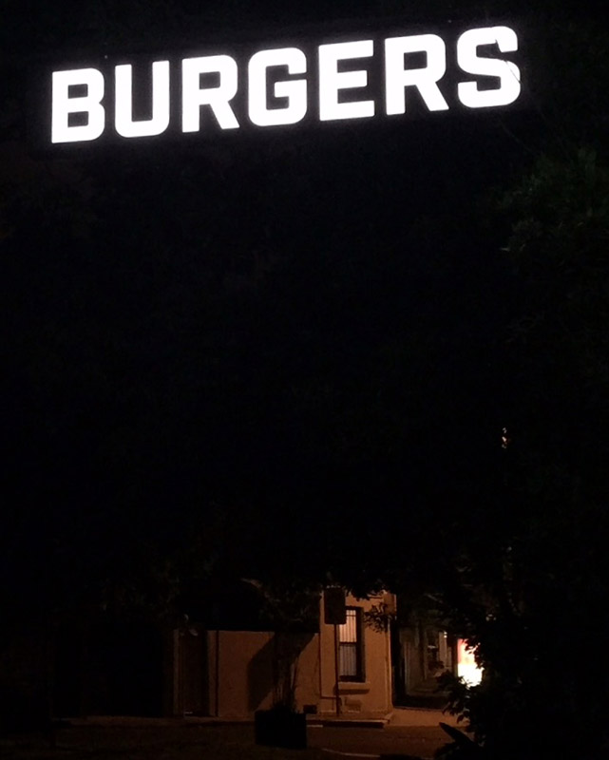
The Alexandria night-walks give me regular epiphanies, startling little bursts of beauty or revelation that gleam out in sombre-soft places that scowl differently in the day-glare. I noticed this metamorphosis most vividly a couple of years ago when I set myself the whimsical exercise of taking the camera-phone out of my pocket at 22.48 each night while out with the big hound, to see what tiny wonderments might get snared by the lens. Most nights I come home, post-22.48, with some little starburst of poignancy caught inside the camera-phone. I make no big claims for these pictures. They are just a dabbler’s indulgence. But I do share them on Instagram. (You can find them on rossgibson_starburst. )
When I review my years of nocturnal snooping, I find that the nightly epiphanies have combined to map a version of Alexandria that refuses the daily fist of exploitation. The 22.48 revelations help me feel not too badly hurt by the diurnal pummeling as I try to flow through my town in my own way rather than in the way mean Sydney money wants me to go. I can look at the night-pictures in the daytime and tell myself I belong here. I care about the town. And I let myself think it cares about me, as evidenced by the resonance in the pictures. Thus my suburb represents my town. Every night, details emerge as blooming gifts that unfurl Sydney’s fist even as I know it will re-clench every sunrise, when the town’s grabby forces reach again across the roads and parks and drains and sandy hollows, pressing the city’s innate wonder temporarily out of sight again into the underworld. So the cycle goes.
But as we know about Sydney, as I know about Alexandria, the underlying beauty is strong and hard to beat. Who can guess how much longer it can survive, but least until now, the beauty has kept finding a way through, thrilling us beguiled citizens regularly enough even as it maintains us compliant and staggering, paradoxically happy under the fist.
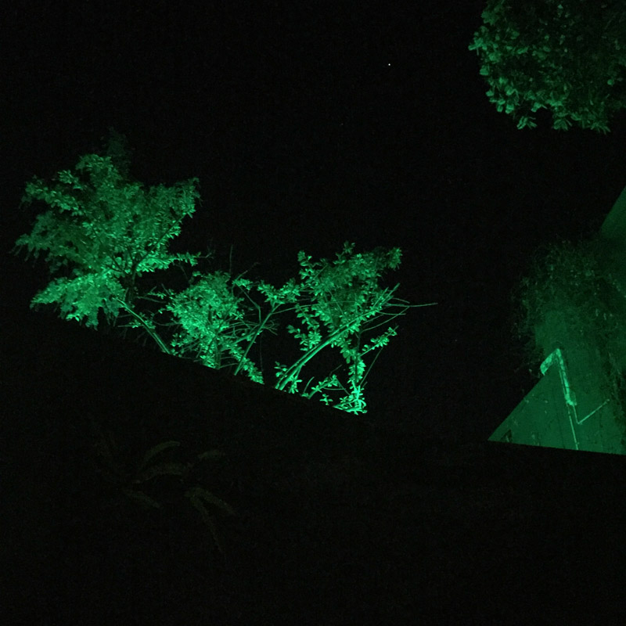
We are grateful to the City of Sydney for funding to commission and publish these essays.

Published June 5, 2018 Cities • Place • Suburbs • Sydney
Part of Writing Place: The SRB has been publishing new writing devoted to place since 2016. All Writing Place essays →


Ross Gibson
Ross Gibson’s work spans several media and disciplines. Recent projects include the Radio National...
Essays by Ross Gibson →

More from Writing Place

In Situ Poetics
In October 2017 I led twenty people around the inner-Melbourne suburb of Brunswick. It was a guided walk, but unlike any most in the group had experienced before. Mine was one of five walks in a public arts project aimed to facilitate aural attentiveness to our environment

Apr. 2020 • Place • Poetry • Suburbs
Climate Crisis Essay: Jennifer Millson floods and fires

Mar. 2020 • Art and artists • Environment and climate • Place • Climate Crisis

